SOUTH KOREA

Creating table sid_skorea.

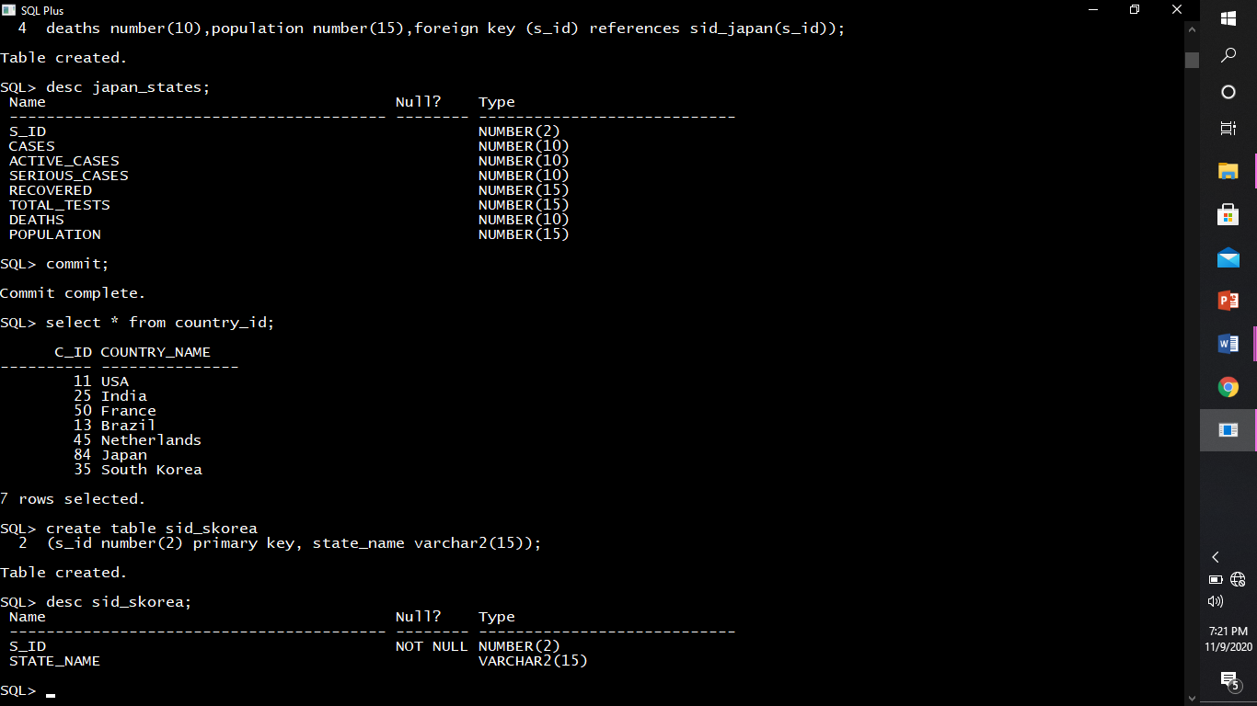

Describing structure of skorea.



Inserting rows into sid_skorea.

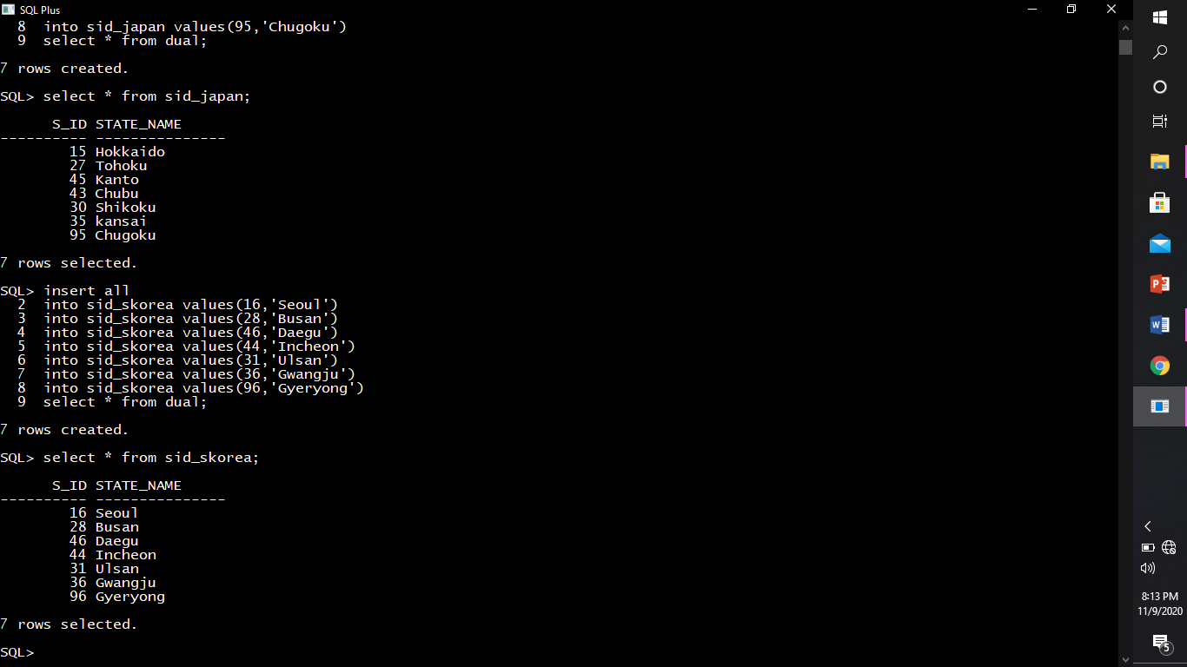

Creating table skorea_states.

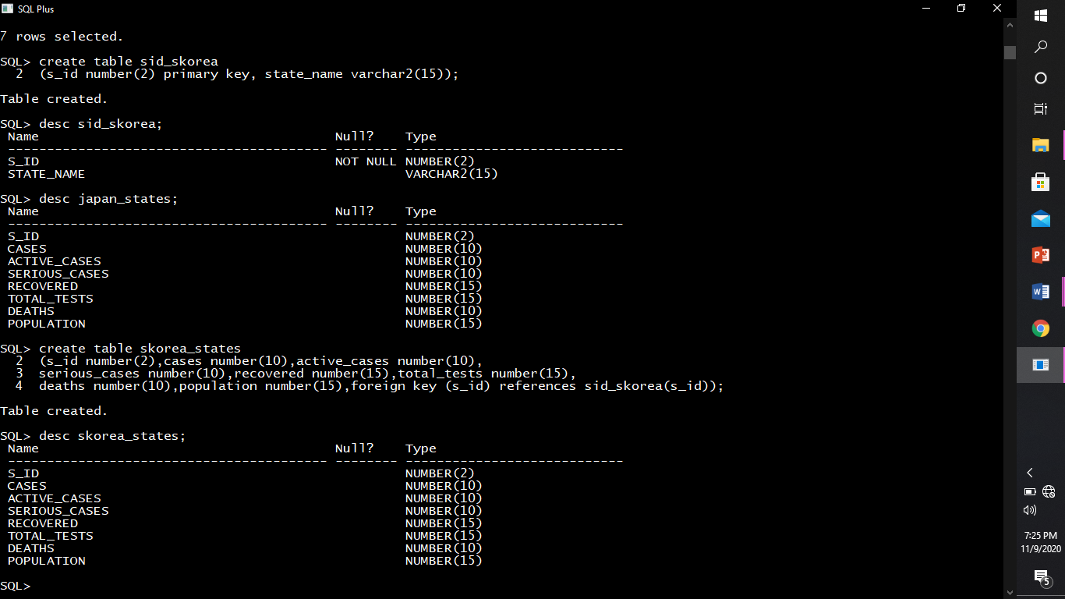

Describing structure skorea_states



Inserting rows into skorea_states.

